Altitude Testing
Altitude testing is a specialty that is now available to our patients in our Littleton and Glenwood Springs Sleep Lab locations.
At Mountain Sleep Diagnostics, we are always looking for ways to improve our patient care and testing facilities. Altitude testing will allow our patients to be tested at the altitude that they live in even though they are being tested in a lower altitude. Why would we offer this?
Colorado has the highest prevalence of Central Sleep Apnea in the United States due to our high altitude. Testing facilities at the higher altitudes where patients live is not only very limited but in some places not available at all. Although Mountain Sleep Diagnostics has one of the highest altitude sleep labs in the United States in Woodland Park, CO (8,570’), this location may not be convenient for all of our patient’s needs or to travel to. Therefore, patients are tested at lower altitudes, and this can create inaccurate testing and misdiagnoses in some patients.
Patients may be diagnosed with Obstructive or Central Sleep Apnea, and may be placed on CPAP. CPAP treatment may not effectively treat or can even cause Central Sleep Apnea, leaving the patients with persistent symptoms including daytime sleepiness and fatigue, as well as oxygen desaturations. With Altitude Testing we can simulate the patient’s home altitude to determine if they develop or continue to have Central Sleep Apnea, or may need the addition of supplemental oxygen to correct hypoxemia that persists on CPAP at their home altitude. This creates the most accurate testing for every patient no matter where they live.
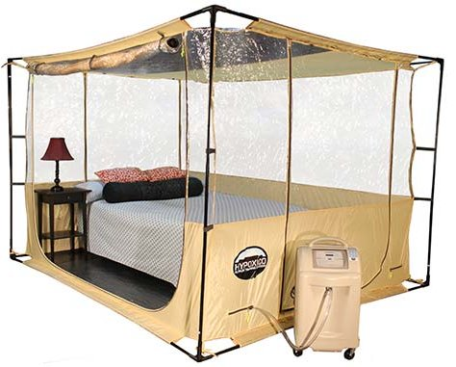We are using the Hypoxico Altitude Testing Tent with the Everest Flow Generator. This allows our patients to still sleep in a traditional bed with all the amenities that all our sleep labs have to offer.

Please call our office at 303-396-5923 to schedule a sleep study in our Altitude Tent in Littleton or Glenwood Springs.

