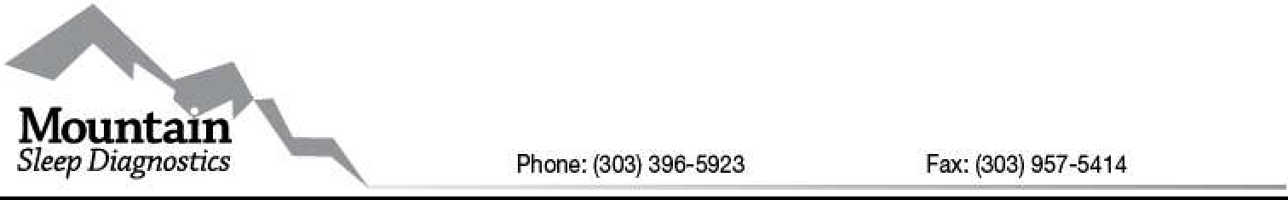

Drop Off Letter

Hello,
,

Your sleep test unit is ready to go. Please contact the Specialist who delivered your unit should you need additional assistance (contact information provided at the bottom of this letter). Please keep this form so you have all pertinent contact information. You can also contact our After Hours Tech by calling our main office number listed above if you are unable to reach our Specialist.

You are scheduled for a:

One Night Study - In Home Polysomnogram Two Night Study - In Home Polysomnogram
Please Sign Consent Required so your results can be sent to your doctor.

Complete Questionnaire - Required for Polysomnogram study interpretation purposes.

Only use test device for the number of nights circled. If you do additional nights you WILL BE CHARGED outside your insurance coverage for an additional $175 a night.

Scheduled Pick-up Date: Monday Tuesday Wednesday Thursday Friday SPECIAL INSTRUCTIONS:

Thank You,

Sarah Johnson – 303-505-6995
In-Home Equipment Specialist Manger Mountain Sleep Diagnostics, Inc
Phone: 303.396.5923 Fax: 303.957.5441

Mountain Sleep Diagnostics, Inc.
Informed Consent for Procedure/Treatment
(To be Completed for Medical Records to be Released)

Proposed Procedure/Treatment: In Home Polysomnogram (Sleep Study)

Request for Provision of Service: I understand that by signing this consent, I indicate my intent to purchase health care services from Mountain Sleep Incorporated and hereby give permission to Mountain Sleep Diagnostics Incorporated and its agents to perform said testing.

Risks and Benefits: The risks and benefits of the procedure have been explained to me, as well as the risks and benefits of refusing the procedure. Benefits of having in home testing done are to gather information for a sleep related diagnoses. This is a non-invasive procedure and risks are minimal. There is a risk of allergic reaction to adhesives if used.

Medical Information Authorization: I hereby authorize my physician/hospital to furnish to an agent of Mountain Sleep Incorporated any and all records pertaining to my medical history, mental or physical condition, services rendered or treatment needed to process claims.

Release of Medical Information to Insurance Carriers:I hereby authorize Mountain Sleep Incorporated to furnish to my insurance carrier(s) or its agent(s) any information concerning my medical history, mental or physical condition, services rendered or treatment need to process claims.

Assignment of Insurance Benefits: I assign and transfer to Mountain Sleep Incorporated any and all rights to receive any insurance benefits otherwise payable to me for provided products or services. I authorize my insurance company to furnish to any agent of Mountain Sleep Incorporated any and all information pertaining to my insurance benefits and status of claims required by my insurance program. I acknowledge that I am responsible for my co- payment, unmet deductible amount or other amount not covered by my insurance program. All out of pocket balances quoted are estimates and cannot be guaranteed until your insurance company processes your claim. You will be responsible for any unpaid balance by your insurance company.

Acknowledgment of Demonstration of Equipment Use: I acknowledge that I was either instructed in person, by video link on the provided instructions or by phone on how to apply the equipment and how the equipment operates. I was also instructed that there is an RPSGT or Respiratory Therapist available 24 hours a day for any in home testing equipment needs.

Acknowledgment for End of Year Policy: I acknowledge that because home sleep studies are performed without a technician present, there is no assurance the test will be successful or meet the requirements needed and a repeat study may be needed. I am aware if testing must be repeated for any reason; I will be responsible for meeting the re- set of my deductible for any scheduling after the start of the New Year. I understand that MSD must bill my Insurance for the day of the SUCCESSFUL study.

I acknowledge that no guarantees, either expressed or implied, have been made to me regarding the outcome of any treatments and/or procedures. I understand that it is impossible to make any guarantees regarding the outcome of any medical treatment or process.

Printed Name Authorized Signature

Today’s Date

Patient’s Name: DOB:
Height: in. Weight: lbs. BMI: kg/m² Neck Size: in.

Epworth Sleepiness Scale

How likely are you to doze off or fall asleep in the following situations, in contrast to just feeling tired? This refers to your usual way of life in recent times. Even if you have not done some of these things recently try to work out how they would have affected you. Use the following scale to circle the most appropriate response for each situation.

0=would never doze 1=slight chance of dozing 2=moderate chance of dozing 3=high chance of dozing

Sitting and reading –––

Watching TV –––

Sitting, inactive, in a public place (theater, meeting etc) –––

As a passenger in a car for an hour without a break ––– Lying down to rest in the afternoon when circumstances permit ––– Sitting and talking to someone –––
Sitting quietly after lunch without alcohol –––

In a car, while stopped for a few minutes in traffic –––

Total 0

Page 1 of 3

CATEGORY 1
- Do you snore?
Yes No
Don’t know
If you snore:
Modified Berlin Questionnaire

7. During your waking time, do you feel tired, fatigued or not up to par?
Nearly every day 3-4 times a week

- Your snoring is:
Slightly louder than breathing As loud as talking
Louder than talking
Very loud – can be heard in adjacent rooms
- How often do you snore
Nearly every day 3-4 times a week 1-2 times a week 1-2 times a month
Never or nearly never
- Has your snoring ever bothered other people?
Yes No
Don’t Know
- Has anyone noticed that you quit breathing or have apneic events during your sleep?
Nearly every day 3-4 times a week 1-2 times a week 1-2 times a month
Never or nearly never

CATEGORY 2
- How often do you feel tired or fatigued after your sleep?
Nearly every day 3-4 times a week 1-2 times a week 1-2 times a month
Never or nearly never
1-2 times a week 1-2 times a month
Never or nearly never
- Have you ever nodded off or fallen asleep while driving a vehicle?
Yes No
If Yes:
- How often does this occur?
Nearly every day 3-4 times a week 1-2 times a week 1-2 times a month
Never or nearly never

CATEGORY 3
- Do you have high blood pressure?
Yes No
Don’t know

CATEGORY 4
- Have you ever woken up choking or gasping?
Yes No
Don’t know

- Are you easily or frequently woken up from sleep?
Nearly every day 3-4 times a week 1-2 times a week 1-2 times a month
Never or nearly never

Page 2 of 3

Patient History Questions
Have you ever been diagnosed or treated for any of the following conditions?

Heart disease: Diabetes:
Lung disease: Insomnia: Narcolepsy: Sleeping Medication:
Yes No
Yes No
Yes No
Yes No
Yes No
Yes No
Stroke: Depression: Sleep apnea:
Nasal oxygen use: Restless leg syndrome: Morning headaches:
Yes No
Yes No
Yes No
Yes No
Yes No
Yes No

Scoring Berlin questionnaire
Adapted from: Table 2 from Netzer, et al., 1999. (Netzer NC, Stoohs RA, Netzer CM, Clark K, Strohl KP.
Using the Berlin Questionnaire to identify patients at risk for the sleep apnea syndrome. Ann Intern Med. 1999 Oct 5;131(7):485-91).

The questionnaire consists of 3 categories related to the risk of having sleep apnea. Patients can be classified into High Risk or Low Risk based on their responses to the individual items and their overall scores in the symptom categories.

Categories and scoring:

Category 1: items 1, 2, 3, 4, 5. Item 1: if ‘Yes’, assign 1 point
Item 2: if ‘c’ or ‘d’ is the response, assign 1 point Item 3: if ‘a’ or ‘b’ is the response, assign 1 point Item 4: if ‘a’ is the response, assign 1 point
Item 5: if ‘a’ or ‘b’ is the response, assign 2 points
Add points. Category 1 is positive if the total score is 2 or more points

Category 2: items 6, 7, 8 (item 9 should be noted separately). Item 6: if ‘a’ or ‘b’ is the response, assign 1 point
Item 7: if ‘a’ or ‘b’ is the response, assign 1 point
Item 8: if ‘a’ is the response, assign 1 point
Add points. Category 2 is positive if the total score is 2 or more points

Category 3 is positive if the answer to item 10 is ‘Yes’ OR if the BMI of the patient is greater than 30kg/m2. (BMI must be calculated. BMI is defined as weight (kg) divided by height (m) squared, i.e., kg/m2).

Category 4 is not part of the Berlin questionnaire, however it is necessary for some insurance companies.

High Risk: if there are 2 or more Categories where the score is positive
Low Risk: if there is only 1 or no Categories where the score is positive

Additional Question: item 9 should be noted separately.

Page 3 of 3
MSD Form 18-B

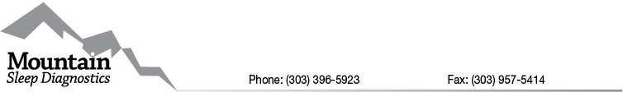

T3-NOX INSTRUCTIONS
Dear Mountain Sleep Patient,

Enclosed is your In Home Sleep Study Kit.

Please wear the device for ONE NIGHT ONLY. You must wear the unit the day of delivery. Your unit must be returned the day scheduled for pick up or there will be an additional charge of $100.00 for every day unit has not been returned.

Instructions and back-up batteries have been provided with your unit. Should you need additional assistance, you may contact the In-Home Equipment Specialist who delivered your study (contact information has been included in your drop off letter). You may also go to the following link to watch an instructional video at https://www.youtube.com/watch?v=CteI_GhyP9g&t=14s which will show you how to set up and use your sleep study equipment. The unit will automatically shut itself off after 7 hours of recording time. Please make sure to get at least 4 hours of sleep, or study will need to be repeated.
You may use a band-aid or medical tape around the bottom of the finger piece to help it stay on better. Use whichever finger is most comfortable for you. If you get up to use restroom during night please leave your test unit on. Only remove if you are not going back to bed.

Pick-up and delivery times are from 8:00 a.m. until 5:00 p.m. If you will not be home or wish to not be disturbed, please leave unit outside your door so that we may pick it up on the scheduled return date.

Thank you and happy data collecting!

Sarah Johnson
In-Home Equipment Specialist Manager Mountain Sleep Diagnostics, Inc

IF THE ATTACHED PAPERWORK IS NOT COMPLETED AND RETURNED WITH THE UNITS WE WILL BE UNABLE TO RELEASE YOUR REPORT TO YOUR PHYSICIAN UNTIL IT IS RECEIVED COMPLETED!

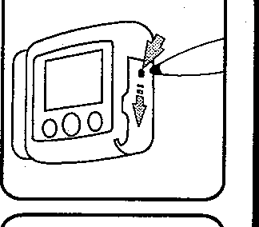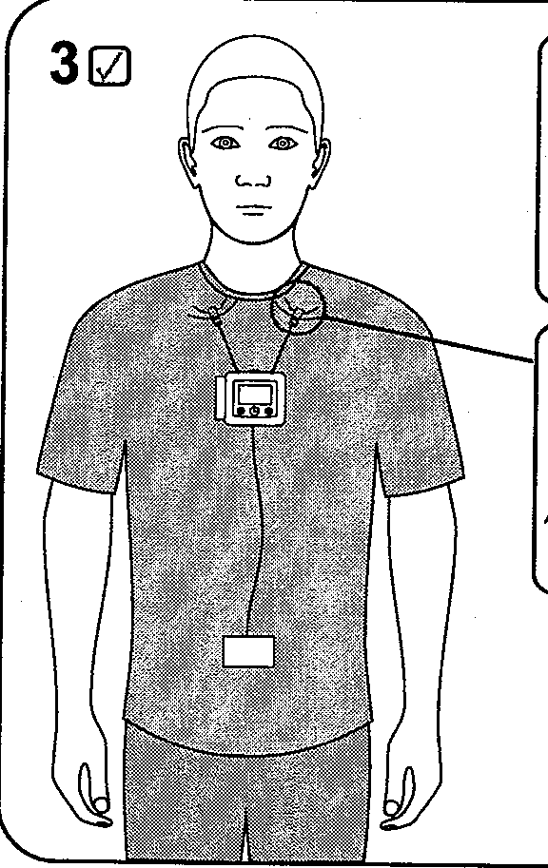PLEASE PUT EVERYTHING ON BEFORE YOU TURN ON UNIT
10
I- AA +

@
aW
l1't
CLIP TO SHIRT
nr§l
20
BUTTON NEEDS TO BE PUSHED TWICE

na

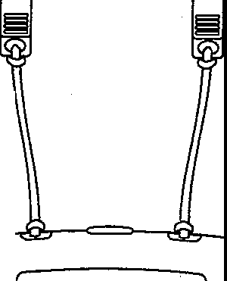
D
© (1K) Q)

PUSH ONCE TO TURJ."'\f ON
I ; : □□:□31
©00

PUSH 2ND TIME AS PROMPTED'At D HOLD
PLEASE BE CAREFUL TO NOT DAMAGE DOOR

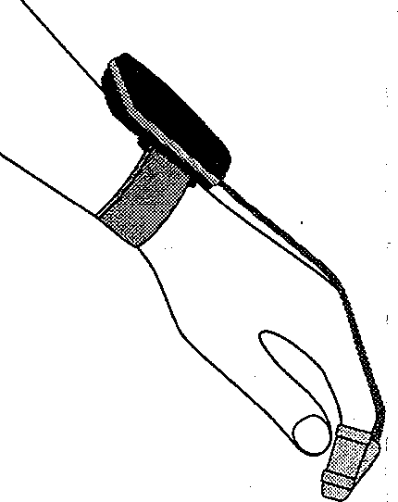
50
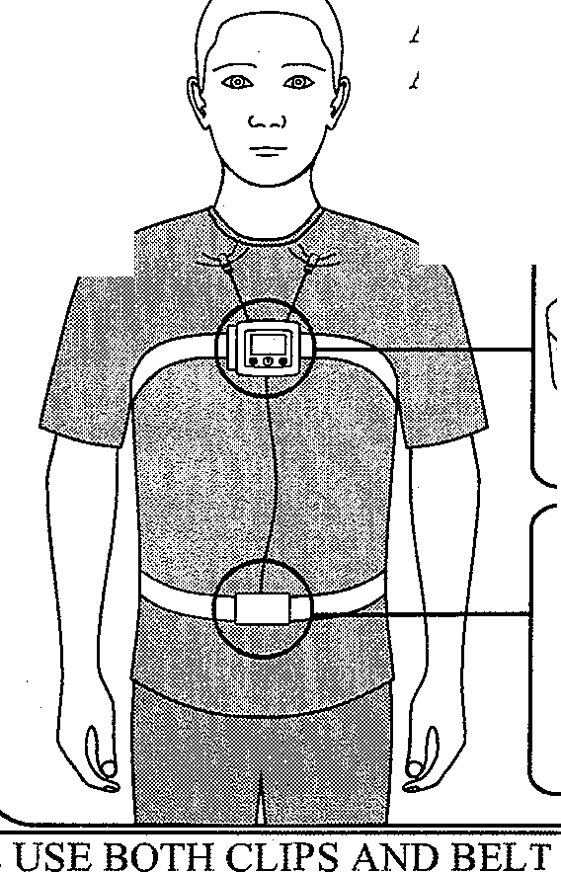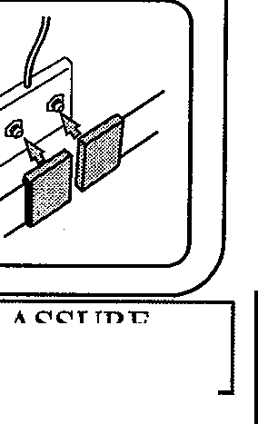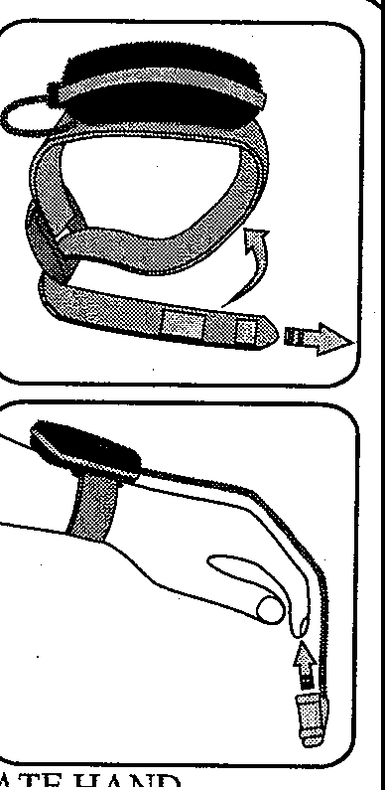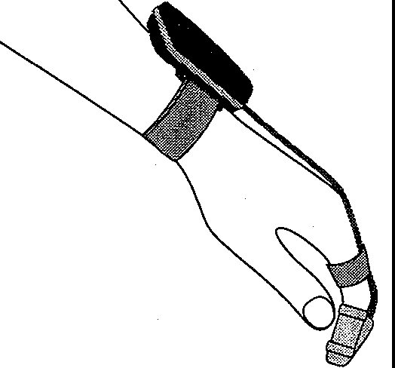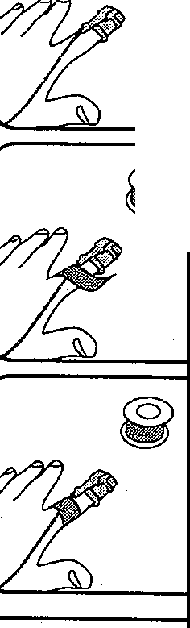PLEASE USE NON DOMINATE HAND
40
BELTS SNAP IN PLACE AND ARE ADJUSTABLE
f
l
fJ$Y
'
PLEASE USE BOTH CLIPS AND BELT TO ASSURE UNIT STAYS IN PLACE
60
TAPE OR BAND-AID CAN BE USED IF YOU FEEL
NECESSARY TO HELP KEEP IN PLACE
UNIT IS WIRELESS AND TURNS ON WHEN CHEST UNIT IS TURNED ON

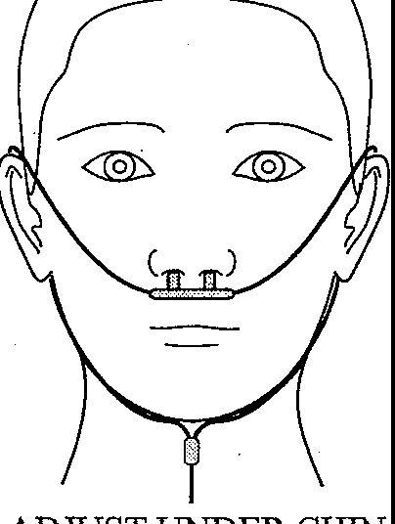
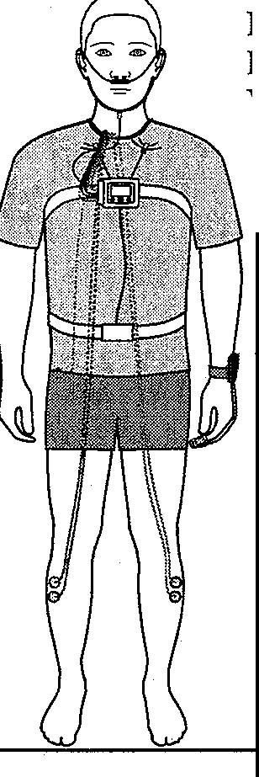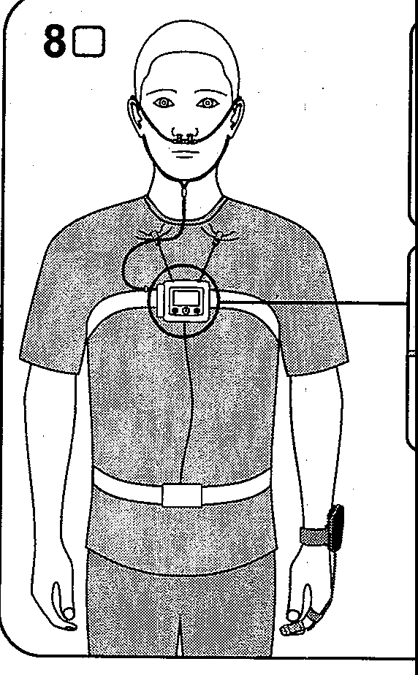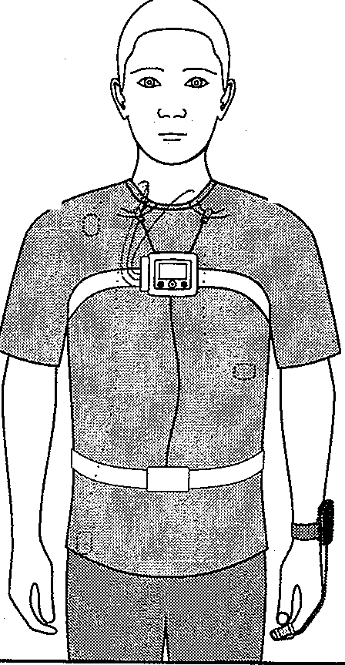100
70

t.
W?
a
ADJUST UNDER CHIN TO KEEP IN PLACE
LEADS ARE NOT REQUIRED FOR YOUR TEST
I
c9
1Q]
90
LEADS ARE NOT REQUIRED FOR YOUR TEST

UNIT IS ON A TIMER AND WILL TURN OFF BY ITSELF

IF YOU GET UP DURING NIGHT DO NOT REMOVE ANY PART OF TESTING DEVICE UNLESS YOU ARE NOT GOING BACK TO BED

PLEASE LOOK TO SEE THERE IS A READOUT ON WRIST UNIT TO ASSURE INFORMATION IS GETTING RECORDED

IF YOU HAVE ANY QUESTIONS PLEASE CALL DRIVER NUMBER INCLUDED IN YOUR INFOR.t\1ATION PACKET

I

©2011 Nox Medical

