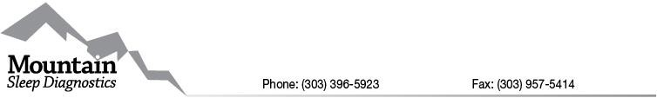

Medical Records Release Form

By signing this form, I authorize you to release confidential health information about me, by releasing a copy of my medical records, or a summary or narrative of my protected health information, to the physician/person/facility/entity listed below.
Patient Name: Date of Birth:

The information you may release subject to this signed release for is as follows:

- History&Physical
- Care Plan
- Lab Reports
- Pathology reports
- Treatment Record
- Medication List
- Progress Notes
- Radiology Reports
- Operative Reports
- Complete Record
- Hospital reports
- Other

Release my protected health information to the following physician/person/facility/entity/ and or those directly associated in my medical care:
Name: Address: City, State, Zip:

The purpose/reason for this release of information is as follows:

